**Membership Application to join**

**Friends of Inglewood Triangle**

Thank you for seeking to join us.

Our current membership fee is $10 per year and

we renew memberships on 1st January of each year.

**Please complete your details below:**

|  |  |
| --- | --- |
| **Full Name:** |  |
|  |  |
| **Address:** |  |
|  |  |
| **Email:** |  |
|  |  |
| **Contact Number:** |  |

**You can pay your membership fee by bank transfer:**

**Bank:** Bendigo Bank Bayswater

**Account Name:** Friends of Inglewood Triangle

**BSB:** 633000

**Account Number:** 182 686 923

*Please put your name in the reference field.*

**Or you can contact us to discuss other payment methods** (cash, cheque or money order). Unfortunately we do not have credit card facilities.

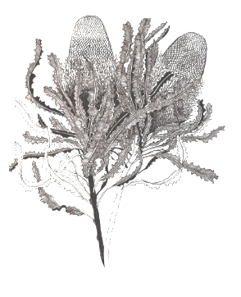

Please forward a copy of this completed form to:

[**inglewood.triangle@gmail.com**](mailto:inglewood.triangle@gmail.com)

Thank you for taking an interest in our precious piece of Banksia woodland and we look forward to working with you.

Friends of Inglewood Triangle