Note 1: UBC's guiding comments in green.

Native Vegetation Policy for WA: Draft for consultation
[Your response due 25 Oct 2021]
Prepared by the Urban Bushland Council WA Inc to assist Members, Supporters and the wider community with their submissions
Find the online survey + Draft NV Policy here: https://consult.dwer.wa.gov.au/native-vegetation/draft-policy/

Find the links to UBC’s information, guides and editable survey docs here: https://www.bushlandperth.org.au/campaigns/native-vegetation-policy/
Does the Draft Native Vegetation Policy (NVP) deliver on the intent outlined in the Minister’s Foreword and the Purpose?
The Minister’s Foreword (page iii) and the Purpose section (page 4) of the consultation draft make some encouraging statements for the protection and management of native vegetation. BUT the content that follows does not adequately deliver on the purpose.
We recommend you complete the survey with this in mind.
The Minister’s foreword (page iii) states
“... first ever Native vegetation policy for Western Australia. It is informed by the valued feedback of more than 1,000 participants, during statewide consultation on native vegetation in 2019–20.
This is the next step in the McGowan Government’s commitment to improve the management and protection of native vegetation. With the right strategies, protecting and enhancing native vegetation can contribute to a strong economic outlook for the state.
Western Australia’s native vegetation and iconic landscapes are unique, biodiverse and internationally renowned. They are worth protecting, now and for future generations. This policy will lay the foundations for enduring reforms to ensure native vegetation is managed strategically, transparently and with a clear view to the future.
The policy will improve agency collaboration to address the challenges that results in cumulative loss of important native vegetation ……
The McGowan Government acknowledges the challenges of caring for the state’s unique native vegetation, given competing priorities and the complexity of its management.”
The Purpose (page 4) states....
“The State Government recognises the need to:
- prevent the extinction of threatened species;
- protect areas of high conservation value; and
- achieve a nett gain in native vegetation extent.

This policy is a necessary first-step in building the systems, frameworks, data and awareness required to achieve this through future reforms.”
NOTE: See below, the UBC Submissions Workshop 7/10/2021 recommends a revision of the purpose to focus on PROTECTION of native vegetation.

The Policy Statement (page 5) states....
“Western Australia’s native vegetation is of great value – ecologically, socially, culturally and economically. To protect and enhance it now and for the future, State Government agencies will ensure that their decisions on native vegetation are coordinated, deliberate, well‑informed and transparent – whether the decision is to protect it, to restore it, or to accept impacts to it in favour of other priorities.”
UBC recommends that you keep returning to these key phrases:
- improve the management and protection of native vegetation
- They are worth protecting, now and for future generations
- lay the foundations for enduring reforms
- achieve a nett gain in native vegetation extent
We urge the State Government to identify strategies with more ambition and urgency to protect and manage existing native vegetation and furthermore deliver a net gain in native vegetation. The southwest WA biodiversity hotspot has been globally identified for conservation priority because it is under threat. Clearing and cumulative impacts of clearing are major threats. Consequently, to achieve a net gain in the SW regions, there must be no more clearing.
The Purpose on page 4 is commended, with some suggested revisions as below.
EXISTING WORDS in Draft NVP | RECOMMENDED REVISION
“The State Government recognises the need to:  - prevent the extinction of threatened species;  - protect areas of high conservation value; and  - achieve a nett gain in native vegetation extent. | “The State Government recognises the need to and will:  - protect all native vegetation;  - prevent the extinction of any native flora species, fauna species, and ecological communities;  - use ecological linkages to connect areas of native vegetation;  - achieve a net gain in native vegetation extent and condition

QUESTION 6. Has the Policy's context adequately covered native vegetation values, opportunities and challenges? (Select all that apply)
No. There are important elements of the context not adequately addressed.

Values
- The significance of the biodiversity of native vegetation in the south west of WA is under-stated and does not include its status as one of 35 globally recognised biodiversity hotspots ‘for conservation priority because it is under threat’. This context with need for its conservation priority must be included.
- The south west region is rich in native species of flora and fauna and ecological communities that do not occur elsewhere. This value should be added.
- The existence of biodiversity ‘sub-hotspots’ within the south west should be included. For example the Perth Metropolitan Region. It is a privilege and human health value for us to live within such a species rich and unique native vegetation area.
- Its value to provide timber should be removed as it implies that native forest logging is still acceptable and also does not reflect the State Government’s recent decision. Native forest logging ‘destroys’ native vegetation, it does not ‘value’ it.
- The same applies to ‘bush products’, eg wildflowers should only be harvested from plantations on land already cleared.
Opportunities
- Shift focus and opportunities to the positive protection and care of our unique native vegetation: The context does not include the opportunity to include an overall policy of no further clearing in the Wheatbelt, and no further clearing on the Swan Coastal Plain. This opportunity would advise all developers and government agencies to confine their developments to suitable lands already cleared.
- There is more focus on management of native vegetation rather than its protection. The concept of balancing management of native vegetation with development and other uses is a missed opportunity for the fundamental need for greatly increased protection of native vegetation. Already under threat and past a tipping point in the south west of WA, further losses must be stopped.
- There is an opportunity for government decision-making to be upgraded under the Clearing Regulations to rigorously enforce the clearing principles. This could stop the net loss of native vegetation in the intensive land use zone (as shown in Figure 1 on page 9) of the south west of WA but only if all ‘exemptions’ are removed for this zone.
- The word ‘protection’ needs to be included in the first sentence under Areas of State Government responsibility on page 7: ‘…. through native vegetation protection and management.’
- There is an opportunity to declare the SW Intensive land use zone as an Environmentally Sensitive Area (ESA). This would mean that Exemptions for the need to apply for a Clearing Permit do not apply. This would provide a greatly needed opportunity to improve governance of native vegetation protection. This ‘opportunity’ should be included.
- Under National frameworks and strategies on page 7: add national requirements for CAR reserve systems in each region. eg for full implementation of Bush Forever as the CAR reserve system for the Swan Coastal Plain portion of the Perth Metropolitan Region.
- The lack of urgency and ambition are of significant concern. Time is not on our side or the side of our native vegetation.
Challenges
- Balance is the wrong concept: The many challenges are described. But the concept of ‘balancing’ priorities such as development, and community safety with ecological sustainability is vague and often not consistent with much needed biodiversity protection and management. For example roadside clearing in the seriously over-cleared Wheatbelt is not justifiable on the grounds of ‘community safety’.
- The concept of ‘ecological sustainability’ is defined in the Glossary under the name ‘Ecologically sustainable development’ and is vague and is thus open to various and selective interpretations. A rigorous definition of sustainability (The Natural Step) is ‘In a sustainable society, nature is no longer being destroyed’. Ecological sustainability should mean no net loss of native vegetation’.
- A major challenge is to stop using offsets to permit clearing of native vegetation which is supposed to be protected under the clearing principles in the Clearing Regulations.
- The challenge is that legal enforcement of the spirit and intent of the clearing regulations needs to be applied by government under the clearing regulations so that clearing is not permitted if it is at variance with one or more of the clearing principles.
- The apparent lack of urgency in protecting existing native vegetation and establishing large scale ecological restoration to ensure no net loss of native vegetation is alarming.

QUESTION 7. How suitable are the guiding principles in providing a contemporary foundation for managing native vegetation? (Select all that apply)
The guiding principles are broadly suitable
There are elements to be addressed (use text box below)
Please provides details on missing elements in the text box below.
The Guiding principles (page 8-9) state....
 | EXISTING WORDS in Draft NVP | RECOMMENDED REVISION
Values
1 | Native vegetation is vital for life on earth and is worth protecting and enhancing. All Western Australians depend in some way on the ecosystem services and co-benefits it provides. | Native vegetation is vital for life on earth and is worth protecting and enhancing for its intrinsic values. All Western Australians depend on the ecosystem services and co-benefits it provides.
2 | Western Australia’s unique flora and iconic ecosystems are nationally and globally significant for biodiversity conservation. Ensuring their protection and sustainable use is an obligation of all levels of government. | Western Australia’s unique flora and iconic ecosystems are nationally and globally significant for biodiversity conservation. Ensuring their protection and sustainable use is an obligation of all levels of government.
3 | Native vegetation is of cultural value to Aboriginal people, who have a long history of sustainable management and use of native vegetation. | Native vegetation is of significant cultural value to Aboriginal people, who have a long history of sustainable management and use of native vegetation.
4 | Native vegetation sustains community health and wellbeing and provides a unique sense of place. | Native vegetation helps sustain community health and wellbeing and provides a unique sense of place.
5 | Native vegetation is of economic value. It sustains important sectors of the economy and provides valuable ecosystem services that are costly to replace.
Practice
6 | Conservation of biological diversity and ecological integrity should be fundamental considerations in managing native vegetation. | Conservation of biological diversity and ecological integrity are fundamental considerations in protecting and managing native vegetation.
7 | A comprehensive, adequate and representative (CAR) reserve system is an important mechanism for conserving native vegetation, species and communities. | A comprehensive, adequate and representative (CAR) reserve system is essential for conserving native vegetation, species and communities.
8 | Stewardship of native vegetation by all land managers is vital to ensure landscape health – including through its integration with other productive land uses (e.g. agriculture, mining), or through its ecologically sustainable use (e.g. beekeeping, pastoralism). | Stewardship of native vegetation by all land managers is vital to ensure landscape health.
9 | Maintaining the ecosystem services and co-benefits of native vegetation is a shared responsibility. The health, diversity and productivity of native vegetation must be maintained or enhanced for the benefit of current and future generations. | Maintaining the ecosystem services and co-benefits of native vegetation is a shared responsibility. The principle of intergenerational-equity means that the health, diversity and productivity of native vegetation must be maintained or enhanced for the benefit of current and future generations.
10 | Decision-making for vegetation must be underpinned by sound science, reliable information on its ecological, social, cultural and economic values, and understanding of cumulative impacts. Where there are threats of serious or irreversible damage, lack of full scientific certainty should not be used as a reason for postponing measures to prevent environmental degradation. | Decision-making for vegetation must be underpinned by sound science, reliable information on its ecological, social, cultural and economic values, and understanding of cumulative impacts. The precautionary principle means that, where there are threats of serious or irreversible damage, lack of full scientific certainty should not be used as a reason for postponing measures to prevent environmental degradation.
Opportunities and challenges
11 | Ecologically sustainable development is essential to the wellbeing and prosperity of Western Australians, now and into the future, and requires balancing environmental, economic and social considerations in decision-making. | Ecologically sustainable development is essential to the wellbeing and prosperity of Western Australians, now and into the future, and requires protection of native vegetation and its environmental values.
12 | Traditional owners with their rich cultural knowledge of ecosystems have roles to play in co-managing, conserving and restoring native vegetation, and in planning for its management. | Traditional owners with their rich cultural knowledge of ecosystems have roles to play in co-managing, conserving and restoring native vegetation, and in planning for its management.
13 | Native vegetation can help mitigate global climate change by sequestering carbon. Conversely climate change, including its impacts on water, fire and temperature regimes, poses a major risk to the health of native vegetation. | Native vegetation helps mitigate global climate change by sequestering carbon. Conversely climate change, including its impacts on water, fire and temperature regimes, poses a major risk to the health of native vegetation.
14 | The condition and extent of Western Australia’s native vegetation is declining. Addressing the decline requires coordinated management across all land tenures, supporting connectivity and maintenance of ecosystem function. | The condition and extent of Western Australia’s native vegetation is declining. In some bioregions it has reached critical levels. Addressing the decline requires coordinated management across all land tenures, supporting landscape-scale ecological restoration, connectivity and maintenance of ecosystem function of all existing native vegetation.
15 | In the intensive land use zone, in particular the Swan Coastal Plain and the Wheatbelt (as defined in Figure 1 and Glossary), historic clearing has been extensive. A nett improvement in the condition and extent of native vegetation can be achieved through strategic coordination and stewardship across sectors, and will restore landscape and ecosystem functions. | In the intensive land use zone, in particular the Swan Coastal Plain and the Wheatbelt (as defined in Figure 1 and Glossary), historic clearing has been extensive. A net improvement in the condition and extent of native vegetation must be achieved through no more clearing combined with strategic coordination and stewardship across sectors, to restore landscape and ecosystem functions.
16 | In the extensive land-use zone (Figure 1), native vegetation is subject to a range of degrading processes. Coordinated management of the threats to native vegetation is needed to maintain and enhance the condition and ecosystem function of native vegetation. | In the extensive land-use zone (Figure 1), native vegetation is subject to a range of degrading processes. Coordinated management of the threats to native vegetation is needed to maintain and enhance the condition and ecosystem function of native vegetation.

Strategies and Outcomes (diagram on Page 10)
QUESTION 8. How well do you support the strategies and outcomes?
 | Strongly support | Support | Neither | Opposed | Strongly opposed
Strategies: The four strategies working together to enable policy evaluation and improvement |  |  | ☒
Outcome 1: Native vegetation is conserved protected and restored at landscape scale with no further loss in a biodiversity hotspot | ☒
Outcome 2: Certainty, transparency and data sharing improve are best practice and adequately funded | ☒
Outcome 3: Improved policy, practice and evaluation | ☒
Outcome 4: Native vegetation outcomes are achieved, together with other State priorities |  |  |  |  | ☒

GOALS AND APPROACHES
Arranged under four strategies, the goals and approaches will guide delivery of the outcomes, through applying to relevant actions in the roadmap. The goals provide for evaluation of this policy and its implementation.
QUESTION 9. How suitable are the goals and approaches in guiding implementation of the policy?
 | Suitable | Somewhat suitable | Neither | Somewhat unsuitable | Unsuitable
Strategy 1 goals and approaches | ☒
Strategy 2 goals and approaches |  | ☒
Strategy 3 goals and approaches | ☒
Strategy 4 goals and approaches |  | ☒

How would you refine or improve the strategies and outcomes?
Please provide details on improving outcomes below.
We / I propose that the Outcomes be modified to be stronger in intent and thus better deliver net gain in native vegetation as follows:
Outcome 1: Native vegetation is protected and restored with no further loss in a biodiversity hotspot.
Outcome 2: Certainty, transparency and data sharing are best practice and adequately funded. This is an urgent outcome in the protection of native vegetation
Outcome 4: Native vegetation outcomes are achieved. “Other State priorities” have already had due consideration and should not be included in this Outcome. It is time to act for native vegetation.

STRATEGY 1 – PLANNING, COLLABORATION & COORDINATION
Goals & Approaches, Opportunities, Agencies & Stage
The goals around planning, collaboration & coordination are supported. The approaches to achieving these goas are supported. However, the roadmap opportunities (actions) are vague and ambiguous, and we could not directly match the goals and approaches to the roadmap opportunities (actions).
We identify an opportunity for environmental NGOs to engage with State Government departments to develop relationships and to engage in the respective legislation to foster the outcomes stated in the policy. We support Whole of Government strategies and look forward to their success.
The reference in the roadmap to actions around offsets is not supported – we cannot see how offsets can help deliver net gain in native vegetation.

STRATEGY 2 – CONTEMPORARY SYSTEMS & PRACTICE
Goals & Approaches, Opportunities, Agencies & Stage
The goals around contemporary systems and practice are supported. The 3 goals and their approaches around clear, regionally tailored objectives and priorities are supported and welcomed as are the improvements to data availability and accessibility. However, the intersection of goals and approaches with the roadmap is hard to follow. Furthermore, our view is that that more needs to be added to the roadmap opportunities (actions) to deliver on the goals and approaches.
We call for improved clarity in wording in the goals and approaches to overcome suspicion around
- the term “certainty” – certainty for whom?
- sourcing comprehensive data and whether it would meet quality and validity thresholds
When looking at the roadmap for opportunities (aka actions) – the view is that these need to be clarified, strengthened, and supplemented. One of the Actions (opportunities) should be to critically evaluate the accuracy and validity of the data and to provide the funding and resources to enable this. We support moving 2.3 to Stage 1. Additionally, there is no reference to the role of LGAs and how they would action the goals and approaches. This omission should be corrected.
In this section we would like to see reference to
- Early referral to the EPA being mandatory
- EPA should not negotiate unilaterally with developers
- WAPC should cease putting through scheme amendments without considering submissions

Strategy 3: Build and share knowledge (page 12) states....
 | EXISTING WORDS in Draft NVP |  | RECOMMENDED REVISION
 | GOALS | APPROACHES
a | Data systems promote information sharing across State Government and with stakeholders. | - Improve mapping, monitoring and information systems for tracking outcomes and improving policy and practice.  - Use sound science, risk assessment, monitoring, reporting and continuous improvement to inform decisions on native vegetation management.  - Continue to enhance native vegetation knowledge, and systems for its sharing, analysis and use. iv) Use traditional and local knowledge of native vegetation to inform objectives, priorities and policy-making. | Support all Goals and approaches.
b | Statewide mapping and monitoring is developed, enabling a whole-of-state view of issues and trends.
c | Integration with decision data which allows policy and practice to be evaluated and improved.

Roadmap: Priorities and opportunities (page 13) states
EXISTING WORDS in Draft NVP | 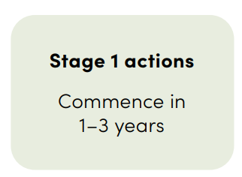 | 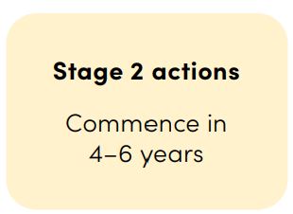 | 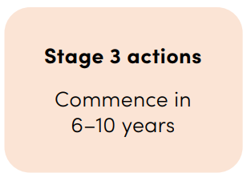
RECOMMENDED REVISION | Stage 1 actions  Commence immediately | Stage 2 actions  Complete in 2 years | Stage 3 actions  Complete in 3-4 years
Strategy 3: Build, share and use knowledge to improve (page 16) states....
EXISTING WORDS in DRAFT
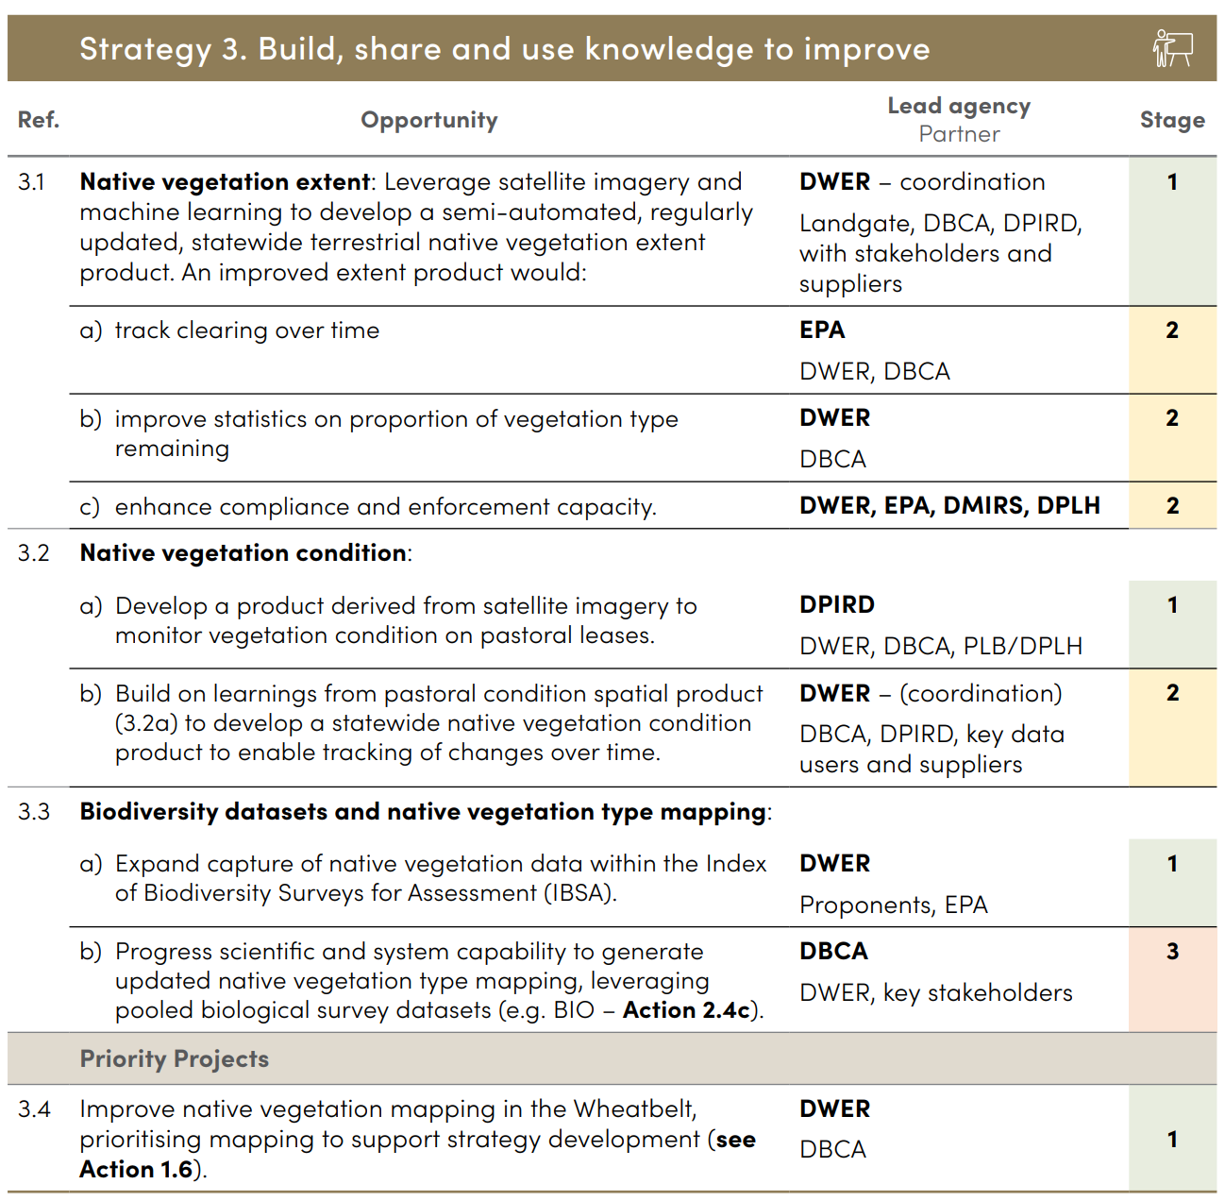 | 1  1  1  1  1  1  2
The goals around build and share knowledge are supported. The three goals and their approaches around better mapping, monitoring and information systems for native vegetation management are strongly supported. However, the intersection of goals and approaches with the roadmap is hard to follow.
The timelines in the roadmap are too extended – there is an urgency to tracking clearing, enhancing compliance and improving statistics on vegetation types (Ref 3.1 (a), (b) and (c)). These should be moved into Stage 1.
When looking back at the desired outcomes, this section of the policy seems to progress parts of Outcomes 2 & 4 (improving certainty, transparency & data sharing; and native vegetation objectives are achieved). They appear to have little impact on conserving and restoring native vegetation or on improving policy practice and evaluation.
Strategy 4: All sectors enabled (see page 12)
Added words are shown in green.
 | Goals | Approaches
a.  b.  c.  d. | State Government policy settings require, inspire, and enable conservation and restoration of native vegetation, across public and private sectors.  Sustainable jobs derive from Western Australia’s unique flora, vegetation types, fauna and landscapes.  Awareness of native vegetation values and ecosystem services is raised.  Native vegetation is protected and managed. | i) Build public understanding of the critical contribution of native vegetation to community wellbeing.  ii) Manage native vegetation in ways that deliver social and employment opportunities for traditional owners, other Aboriginal people and Western Australians.  iii) Provide incentives and funding to support voluntary conservation and restoration on various land tenures, to support biodiversity, ecosystems and their co-benefits.  iv) Provide funding for State Government protection and management of native vegetation.  v) Explore and provide strategic coordination of funding streams (e.g. environmental or carbon offsets, restoration funding, Land for Wildlife , tourism opportunities) to deliver positive native vegetation outcomes.

Strategy 4: All sectors enabled (See page 17)
Ref. | Opportunity | Lead agency  partner | Stage
4.1 | Progress and improve how incentives and pricing are used to support good stewardship of native vegetation. | DWER coordination | 1
 | a) Delete this item.
 | b) Support and promote agricultural, pastoral and forestry land uses that fix carbon, support biodiversity, promote soil health and other ecosystem services. | DPIRD  DWER, FPC, PLB/DPLH | 1
4.2 | Environmental offsets:  Delete this section 4.2. Environmental offsets do not align with the intent and purpose of Native Vegetation Policy. Note accordingly that the following sentence in the Minister’s foreword on page iii must be deleted:  “A more strategic, flexible approach to offsets will improve certainty, ensuring offsets meet regional environmental priorities and maximise co benefits, including jobs.”  The environmental offsets approach is flawed as it is being used to justify clearing of native vegetation that is supposed to be conserved. This is especially the case in the South West biodiversity hotspot.
4.3 | Enhance the effectiveness of risk mitigation programs across the state to reduce the risk of bushfire to the community and to native vegetation ecosystems.  Increase the capacity for fast detection and fast fire fighting response to wildfires. | DFES, DBCA  Local governments, local fire brigades | 1
4.4 | Plan for and provide Aboriginal engagement in native vegetation and bushfire management through existing and future initiatives. | DBCA, DFES,  LGAs | 1
4.5 | Leverage Western Australia’s iconic vegetation to create regional jobs in tourism and conservation. | JTSI  DBCA, Treasury | 1
4.6 | Develop and implement a Wildflower Friendliness Rating Scheme, to reward LGAs with wildflower-friendly roadsides. | Wildflower Society of WA  JTSI, DWER | 1
4.7 | Build on existing strategies and the Bush Forever program to enhance urban bushland. | DPLH  Local governments | 1

ROADMAP
To achieve the intended outcomes, this policy identifies a roadmap of priorities and opportunities to be implemented primarily through State Government actions. These actions comprise a coordinated, whole-of-government approach.
QUESTION 10. Which roadmap actions are most important?
You may answer as few or as many as are relevant.
 | High priority | Medium priority | Low priority
Regionally tailored objectives and priorities (Actions 1.1 - 1.3) | ☒
Monitor and evaluate policy implementation (Action 1.4) | ☒
Review of existing mechanisms for protecting native vegetation (Action 1.5) | ☒
A focus on the Wheatbelt (Action 1.6 and 3.4) | ☒
Transparency of decision-making (Actions 2.1 - 2.3) | ☒
Systems to support decision-making and data sharing (Action 2.4) | ☒
Improve efficiency and clarity of the clearing permit process (Action 2.5) | ☒
Native vegetation mapping and monitoring (Actions 3.1 to 3.3) | ☒
Incentives and pricing for good stewardship (Action 4.1) | ☒
Environmental offsets (Actions 4.1a) & 4.2) |  |  | ☒
Other (use textbox) | ☒
If your response is in relation to a particular action(s), please include the action number(s).
Please provide your answer in the text box below.
Our overarching comments about this section are
The timelines proposed in this section are insufficient for delivering the task at hand and they do not portray the sense of urgency. We believe the Stage 1 actions should be completed within 2 years; the Stage 2 actions completed in 2 -4 years and the Stage 3 actions completed in 4 – 6 years.
The Roadmap (opportunities or actions) section is vague and repetitive and it is hard to see how they will deliver the purpose and intent expressed early in this consultation draft. However, in summary form all the actions except one are deemed a high priority. Environmental offsets is deemed a low priority and an action that does not support the Purpose of protecting native vegetation and achieving net gain.

UPLOAD A DOCUMENT – THIS IS THE LAST FREE TEXT BOX IN THE SURVEY
QUESTION 11. You can upload documents or supporting information here.
Attached files will be published, where consent has been provided under Question 3. Please ensure any file is virus-free, redacted and ready for publishing.
Please describe the documents you have uploaded, and if relevant which question they relate to.
This is the last opportunity to make a comment in the survey so you might like to include one of these:
A case study from your Friends group that highlights why NVP is important for your patch
Any detailed comments about any section of the policy document
A supporting statement for either your local Friends group submission or the UBC submission
Upload TWS document https://www.wilderness.org.au/western-australias-native-vegetation (7 Ways to protect WA’s most valuable natural asset)

