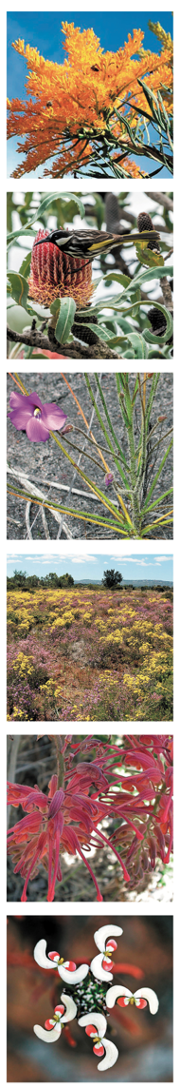
DRAFT 5 Greater Brixton Street Wetlands need YOU!

This SUBMISSIONS GUIDE is brought to you by The Beeliar Group, Friends of Alison Baird Reserve, Friends of Brixton Street Wetlands, Save the Great Brixton Wetlands Alliance, Urban Bushland Council, Wildflower Society of WA and many other groups and individuals.
We encourage you to join us in calling for greater environmental protection of, and sustainable development around, our precious Greater Brixton Street Wetlands and Yule Brook corridor.

The City of Gosnells (CoG) has proposed a F in land use zonings (via amendments 166 and 169 to Town Planning Scheme No. 6 and a Draft Structure Plan 2023) on Whadjuk Noongar boodja, to implement Precincts 2 and 3b of the Maddington Kenwick Strategic Employment Area (MKSEA).

https://yoursay.gosnells.wa.gov.au/mksea
Submissions are now close Monday 28th August
via e-mail (council@gosnells.wa.gov.au), post or ‘Have your Say’ online portal

The MKSEA will have a significant negative impact on the Greater Brixton Street Wetlands (GBSW) Bush Forever Area 387 – a ‘Jewel in the Crown of a Global Biodiversity Hotspot’. These new precincts sit either side of the GBSW and Yule Brook with insufficient buffer zones to protect them, putting hundreds of species of native plants and animals at risk. Some plants that grow nowhere else in the world and are now listed as Critically Endangered could even be rendered extinct.

The complex and sensitive hydrology and the varied soils of the GBSW have contributed to its mega diversity of plant communities and flora species. Ill-considered development and management of the interconnected ecosystems of the GBSW and Yule Brook will inflict heavy direct, indirect and cumulative impacts on the Environmental Protection Authority’s (EPA) Statement of environmental principles, factors, objectives and aims of EIA - 4 April 2023.pdf (PDF, 430.34 KB) four key factors :
- inland waters
- flora and vegetation
- fauna and
- social surrounds.

Impacts include sub-standard Local Water Management Strategies (LWMSs); inadequate, unscientific buffer widths proposed by the proponent and inevitable safety upgrades for use by industrial traffic of the currently dangerous roads. These impacts were almost all totally ignored or summarily dismissed by the proponent. However, they have now been quantified by scientists for the community and will be shared and submitted.

To ensure industry does not adversely change water balance that is so critical to the GBSW and also impact other EPA key factors, we are calling on the City of Gosnells to:
- Implement evidence-based buffer zone locations and widths (100m) that better protect Yule Brook and GBSW
- Reconsider and reduce the development footprint as per The Beeliar Group (TBG) mapping
- Commission an independent, scientific, peer-reviewed and publicly transparent Water Management Strategy AUDIT and implement and monitor the resultant best practice Water Management Strategy
- Rigorously apply the Environmental Protection Authority’s (EPA) 2022 guidance provided in ‘Environmental Values and Pressures for the Greater Brixton Street Wetlands on the Swan Coastal Plain', in accordance with Section 16(j) of the Environmental Protection Act 1986’
- Commission the first ever, detailed fauna survey of the GBSW and MKSEA
- Update and publish the Environmental Review Document (ERD) and its Appendices to incorporate the factual basis of each assessment from the contemporary knowledge base rather than from the now-outdated information used in the current ERD
- Intentionally plan and deliver the precautionary principle, intergenerational equity conservation of biological integrity and waste minimisation (EPA 2023)
- Intentionally plan and deliver against all relevant legislation, policies, commitments and standards of all three spheres of government to ensure hydrology, flora biodiversity and fauna biodiversity are properly protected and managed
- Intentionally plan and deliver reconciliation with first nations and implement all relevant legislation, policies, commitments and standards of all three spheres of government

Implement evidence-based buffer zone locations and widths (100m) that better protect Yule Brook and GBSW
1
Functional buffers are required for good conservation management – without these the significant natural wonders of the GBSW and adjoining proposed Yule Brook Regional Park will be eroded, degraded and ultimately lost. These buffers are required for:
- the Greater Brixton Street Wetlands (Bush Forever Site 387)
- Conservation Category Wetlands
- Yule Brook
- Crystal Brook
- All Threatened, Priority and other Flora of conservation significance and their habitat
- All vegetation of the Guildford and Forrestfield Vegetation Complexes
- All Threatened, Priority and other Fauna of conservation significance (including invertebrates and Short Range Endemics) and their habitat (eg Carnaby’s Black Cockatoos)
- Federal and State Threatened Ecological Communities (TECs).

The Beeliar Group’s vision for a future Yule Brook Regional Park illustrates the importance of broad and connected buffers. Check out the full presentation on their website. 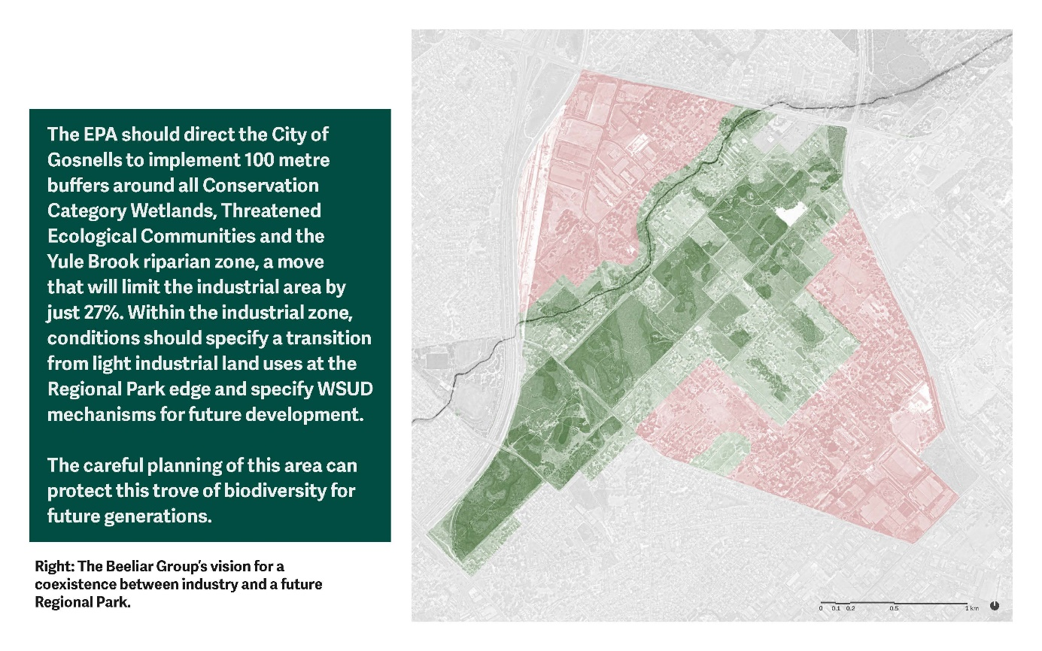
2
Reconsider and reduce the development footprint as per The Beeliar Group (TBG) mapping
We urge the City of Gosnells (CoG), Dept. Planning, Lands & Heritage (DPLH) and the EPA to NOT re-zone these blocks to ‘industrial’ or ‘composite zone’ (or ‘nominal drainage basin’ adjacent to Yule Brook).
The Beeliar Group’s plan doubles the conservation/green area for a 27% reduction in the MKSEA industrial zoning (refer Figure 2). This would improve connectivity of a future Yule Brook Regional Park, reduce the boundary to area ratio of the conservation/green areas, form a critical buffer to supporting and ameliorating the hydrological values and processes (thus reducing impacts on vegetation, Threatened and other flora and fauna) and reduce the impacts of industrial land use with inadequate buffers adjacent to GBSW.
Refer to The Beeliar Group’s website The Beeliar Group – Professors for Environmental Responsibility
3
Commission an independent, scientific, peer-reviewed and publicly transparent Water Management Strategy AUDIT and implement and monitor the resultant best practice Water Management Strategy. This would include review of the current LWMSs and to DESIGN a new, best practice water management strategy and Structure Plan that will truly protect the GBSW and Yule Brook. The current proposal will NOT provide adequate and appropriate ‘on-lot’ and ‘roadside’ water volume and quality structural controls to avoid and minimise the impacts of the planned MKSEA Precinct 2 and 3B water management on GBSW and Yule Brook. Moreover the ‘inherited’ cumulative impacts from other completed or planned projects will have very large and equally poorly mitigated/unmitigated impacts on the GBSW and Yule Brook (Figure 11 of the LWMS for MKSEA Precinct 2). These projects include the MKSEA Precincts 1 and 3A, the planned Tonkin Highway Grade Separated Interchanges (Hale Road and Welshpool Road) and other planned Kenwick/Wattle Grove and Forrestfield catchment industrialisation/urbanisation. The LWMS for MKSEA Precinct 2 shows the inadequately-treated, polluted stormwater inflow from the large catchments of MKSEA Precinct 1, and the Wattle Grove and Tonkin Highway catchments is all planned for conveyance through the deep trapezoid open drain portion of Crystal Brook (in the iconic UWA Alison Baird Reserve in the GBSW) into Yule Brook.

The LWMS should comply with latest version of WA Government ‘Decision Process for Stormwater Management in WA’, updated 2017 https://www.wa.gov.au/government/publications/decision-process-stormwater-management-western-australia. It is especially important for the GBSW that the State Government’s guidance for planning and designing stormwater management systems for urban developments be fully implemented. The first 15mm of any rainfall event needs to be managed on-lot, with estate wide management options also installed.

The use of a LWMSs such as Source Control Stormwater Management (SCSM) negates the requirement of surface detention systems similar to the Multiple Use Corridor (MUC) and the ‘nominal drainage basins’ being proposed. Such a revised design for LWMSs would also ensure improved environmental outcomes for the groundwater-fed GBSW. By maximising triple-bottom-line benefits, SCSM counters the effects of traditional drainage systems that often result in harm to groundwater dependent ecosystems and critical habitat of Threatened wildlife. The installation of detention basins by excavation, or other means, in the clay soils of the lowest lying parts of Precincts 2 and 3B is known to be risky with regard to the very serious impacts associated with acid sulphate soils and groundwater mounding in such settings.
4
Rigorously apply the Environmental Protection Authority’s (EPA’s) 2022 guidance provided in ‘Environmental Values and Pressures for the Greater Brixton Street Wetlands on the Swan Coastal Plain', in accordance with Section 16(j) of the Environmental Protection Act 1986’. Environmental Values and Pressures for the Greater Brixton Street Wetlands on the Swan Coastal Plain.pdf (PDF, 1.31 MB)
It specifically provides advice on expectations for proposals and planning schemes around:
- Traditional owner engagement
- Protection of ecological and hydrological values (note offsets statement)
- Hydrological and hydrogeological investigations
- Stormwater management and drainage
- Buffers
- Cumulative Impacts.
EPA Chair, Professor Tonts said the “EPA expected future activities and development to be compatible with the protection of the environmental values of the Greater Brixton Street Wetlands and would apply particular scrutiny to proposals and planning schemes that may be incompatible with the protection of these values.
“Protection of environmental values through science and coordinated management are critical if this unique area of biodiversity is to survive,” Professor Tonts said.
“This is a chance for us to be proactive and prevent further loss in what is one of the State’s most unique examples of biodiversity.”
It is especially important to note that the Main Roads WA project “Tonkin Highway Grade Separated Interchanges (Hale Road and Welshpool Road)” will be a significant source of cumulative impacts on the GBSW.
5
Commission the first, ever, detailed fauna survey of the GBSW and MKSEA
Such an oversight of this significant knowledge gap for this mega diverse habitat. This research will also clearly demonstrate the close relationships between the variety of plant community habitats and fauna, including with insects, Short Range Endemics and subterranean fauna.
6
Update and publish the Environmental Review Document (ERD) and its Appendices to update the factual basis of each assessment from the contemporary knowledge base rather than from the now-outdated information used in the current ERD
The Environmental Review Documents (ERD) prepared by Emerge Associates for the City of Gosnells, did not appear to make use of the most contemporary (and published) knowledge available from experts of the GBSW including:
- EPA (2015) Perth and Peel @ 3.5 million Environmental impacts, risks and remedies Interim strategic advice of the Environmental Protection Authority to the Minister for Environment under section 16(e) of the Environmental Protection Act 1986 https://www.epa.wa.gov.au/sites/default/files/Publications/Perth-Peel-s16e-interim-advice-2015-web.pdf
- EPA (2022) = Environmental Values and Pressures for the Greater Brixton Street Wetlands on the Swan Coastal Plain', in accordance with Section 16(j) of the Environmental Protection Act 1986 Environmental Values and Pressures for the Greater Brixton Street Wetlands on the Swan Coastal Plain.pdf (PDF, 1.31 MB)
- Lambers H ed (2019) A Jewel in the Crown of a Global Biodiversity Hotspot. Kwongan Foundation and the Western Australian Naturalists Club Inc, Perth.
- Hans Lambers UWA and international team’s recent publications about the ecophysiology of Grevillea thelemanniana.
- V & C Semeniuk Research Group (2001) Hydrological Study of the Greater Brixton Street Wetlands: Report prepared for the Friends of Brixton Street Inc.
7
Intentionally plan and deliver the precautionary principle, intergenerational equity, conservation of biological integrity and waste minimisation as expected under the Environmental Protection Act 1986 (Section 4A)
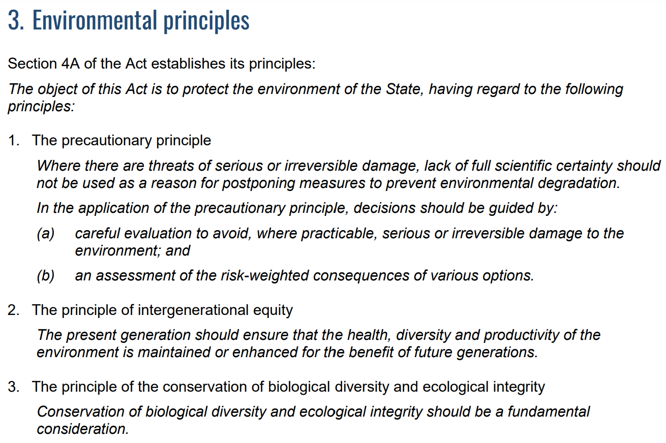
EXTRACT: Statement of environmental principles, factors, objectives and aims of EIA - 4 April 2023.pdf (PDF, 430.34 KB)

8
Intentionally plan and deliver against all relevant legislation, policies, commitments and standards of all three spheres of government to ensure hydrology, flora biodiversity and fauna biodiversity is properly protected and managed including:
- International Union for the Conservation of Nature IUCN (2022) Global Biodiversity Framework
- Govt of WA (2022) WA Native Vegetation Policy (eg no net loss) Native vegetation policy for Western Australia
- Environment Protection and Biodiversity Conservation (EPBC) Act 1999 (eg Matters of National Significance like Carnaby’s Black Cockatoos)
- Govt of WA (1997) Wetlands Conservation Policy https://library.dbca.wa.gov.au/static/FullTextFiles/017818.pdf
- WA Local Government Assn (2013) Policy-Advice-and-Advocacy/Environment/Local-Biodiversity-Program/Guidance-for-the-Integration-of-Biodiversity-into-LPSs.pdf.

8

Intentionally plan and deliver reconciliation with First Nations and implementation of all relevant legislation, policies, commitments and standards of all three spheres of government
Genuinely form a partnership with the Indigenous communities as knowledge holders and custodians of this Whadjuk Noongar boodja including delivering responsibilities under the Aboriginal Cultural Heritage Act 2021

