Mr Ian Cowie 27th August 2023
Chief Executive Officer
City of Gosnells
2120 Albany Highway
Gosnells WA 6110

council@gosnells.wa.gov.au

Dear Mr Cowie,

SUBMISSION: MADDINGTON KENWICK STRATEGIC EMPLOYMENT AREA PRECINCT 2 & 3B
– Amendments 166 and 169 to City of Gosnells Town Planning Scheme No. 6
The Urban Bushland Council WA Inc. (UBC) is pleased to present this submission in response to your invitation to address the issues of relevance to us. We note that these new precincts sit either side of the Greater Brixton Street Wetlands (GBSW) / Bush Forever 387 and Yule Brook. Thank you for the opportunity to comment.

Urban Bushland Council WA Inc (UBC)
The UBC is the peak WA community organisation for urban bushland recognition and protection. UBC is an incorporated, not for profit organisation registered as a charity. We are a voluntary community association with an active membership of 88 volunteer groups (each with their own local membership from 10-165 individuals) and an additional 100 individual ‘supporter’ members – all with a common interest in conservation and protection of areas of urban bushland in WA. https://www.bushlandperth.org.au/.
UBC advocates to all levels of Government for natural areas protection. We do this with limited resources through the amazing efforts of our ‘Friends Groups’ and their many volunteers – from all walks of life ‘working’ to improve and maintain the health of patches of neighbourhood nature. Some of our member groups are active in your City, working with your officers, such as The Friends of Brixton Street Wetlands, South East Regional Centre for Urban Landcare, Nature Reserves Preservation Group, Black Cockatoo Preservation Group, Crestwood Bushland Restoration Group and Friends of Ellis Brook Valley.
UBC has recently celebrated 30 years of advocacy for the protection of urban bushland.

General Points
We note that the City of Gosnells website clearly indicates that these scheme amendments do not propose any changes to the GBSW and infers this is sufficient to protect them. Our submission puts the contrary position – that the future health of the GBSW relies on environmental protection outside the lines drawn on the map for Bush Forever 387.
The Greater Brixton Street Wetlands are located between Precincts 2 and 3B. The proposed scheme amendments do not propose any changes to the existing reservations or Bush Forever sites which apply to these wetlands. https://yoursay.gosnells.wa.gov.au/mksea
UBC believes the MKSEA will have a significant detrimental impact on the Greater Brixton Street Wetlands (GBSW) Bush Forever Area 387 – a ‘Jewel in the Crown of a Global Biodiversity Hotspot’.
We point to the work by ‘The Beeliar Group (TBG) – Professors for Environmental responsibility’ that presents the complexity of the hydrology of this whole area and proposes that buffers of 100 metres will be required to safeguard this precious place. The TBG slideshow is available at
https://thebeeliargroup.files.wordpress.com/2023/08/the-beeliar-groups-vision-for-a-future-yule-brook-regional-park-1.pdf
Slide 5 illustrates the location and importance of the ‘hydroplain’ area of pervious landscape across the Greater Brixton groundwater flownet. TBG have determined that rezoning in its current form cannot go ahead without the strong likelihood of extreme detrimental environmental impacts upon biodiversity, hydrology, and landscape connectivity.
The complex and sensitive hydrology and the varied soils of the GBSW have contributed to its mega diversity of plant communities and flora species. Current proposals will put hundreds of species of native plants and animals at risk. Some plants that grow nowhere else in the world and are now listed as Critically Endangered could even be rendered extinct.
Broad and connected buffers are essential around the GBSW and associated Yule Brook. This is illustrated at Slides 6 and 7 of the TBG slideshow. Furthermore, TBG recommend 100 metre buffers around all Conservation Category Wetlands (CCWs), Threatened Ecological Communities (TECs) and the Yule Brook riparian zone in association with careful Water Sensitive Urban Design (WSUD) planning and implementation across all the MKSEA precincts. This is the best way to protect the megadiverse GBSW, some parts of the Yule Brook and the upper reaches of the Canning River.
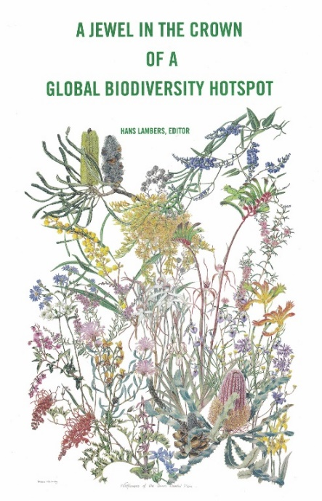
We point to the contemporary work by scientists, specialists, researchers and community conservationists contained in Lambers H ed (2019) A Jewel in the Crown of a Global Biodiversity Hotspot. Kwongan Foundation and the Western Australian Naturalists Club Inc, Perth. With chapters from scientists, specialists and community including Mike BAMFORD, Neale BOUGHER, Adam CROSS, Paddy CULLEN, Elaine DAVISON, Robert DAVIS, Tegan DOUGLAS, Katy EVANS, Sajni GUDKA, Bronwen KEIGHERY, Greg KEIGHERY, Karina KNIGHT, Megan JACEGLAV, Philip JENNINGS, Hans LAMBERS, Peter LANE, Owen RICHARDS, Cate TAUSS, Renata ZELINOVA.
GBSW has long been recognised as having the greatest biodiversity of the entire Swan Coastal Plain/m2 and it is our collective responsibility to protect our natural heritage for its intrinsic value and pass it down to our children and grandchildren.
The Friends of Brixton Street Wetlands are a long-term member of UBC. They have worked for three decades to protect their part of the BF 387 initially from housing and then more recently through their bushcare and community engagement activities. The MKSEA proposals as written represent an insidious and lethal threat to their precious bushland that they will be powerless to counteract. You can read more about their work and contributions in Lambers H ed (2019), p393 in the chapter titled ‘The role of committed citizens as caretakers and protectors of place’.
Ill-considered development and management of the interconnected ecosystems of the GBSW and Yule Brook will inflict heavy direct, indirect and cumulative impacts on the four key environmental factors identified by the Environmental Protection Authority (EPA) Statement of environmental principles, factors, objectives and aims of EIA - 4 April 2023.pdf (PDF, 430.34 KB):

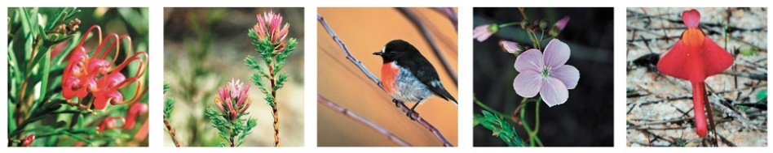
- inland waters
- flora and vegetation
- fauna and
- social surrounds.
The UBC is highly concerned about the direct, indirect, and cumulative impacts of development and conservation/sustainability management actions (or lack of them) on all patches of neighbourhood nature. In this instance we are highly concerned for the proposed Yule Brook Regional Park that includes the Greater Brixton Street Wetlands.

Submission
The Greater Brixton Street Wetlands is not a self-contained, ecological system. It is intricately interconnected with the Darling Scarp and the wider Swan Coastal Plain via unique hydrogeology and hydrology.
Interference with these natural and highly evolved formations and processes, well beyond the current boundaries of the GBSW will have significant, detrimental impacts on the highly sensitive groundwater dependent ecosystems* (GDEs) of the GBSW. In other words, activities in the proposed MKSEA that impact the natural processes of the hydroplain will result in significant ‘MKSEA offsite impacts’ – where the ‘offsite’ is the highly sensitive, mega diverse Greater Brixton Street Wetlands. (*As an example, Gao et al (2020) have demonstrated that the Critically Endangered Grevillea thelemanniana (listed under the EPBC Act in 2018) is dependent on groundwater.)
To ensure the MKSEA development does not adversely change water balance that is so critical to the GBSW and also does not impact key environmental factors EPA (2023), UBC is calling on the City of Gosnells to:
- Implement evidence-based 100 metre buffer zone widths and locations that protect Yule Brook and GBSW and thus reconsider and reduce the development footprint as per The Beeliar Group (TBG) mapping
- Commission an independent, scientific, peer-reviewed, and publicly transparent Water Management Strategy AUDIT and implement and monitor the resultant best practice Water Management Strategy
- Rigorously apply the Environmental Protection Authority (2022) guidance provided in ‘Environmental Values and Pressures for the Greater Brixton Street Wetlands on the Swan Coastal Plain', in accordance with Section 16(j) of the Environmental Protection Act 1986’
- Commission the first ever, detailed fauna survey of the GBSW and MKSEA – and then plan and manage with this contemporary knowledge
- Ensure the Environmental Review Document (including Appendices) incorporates all contemporary knowledge
- Intentionally plan and deliver the precautionary principle, intergenerational equity conservation of biological integrity and waste minimisation (EPA 2023)
- Intentionally plan and deliver against all relevant legislation, policies, commitments and standards of all three spheres of government to ensure hydrology, flora biodiversity, fauna biodiversity and ecological habitats are properly protected and managed
- Intentionally plan and deliver reconciliation with first nations and implement all relevant legislation, policies, commitments, and standards of all three spheres of government
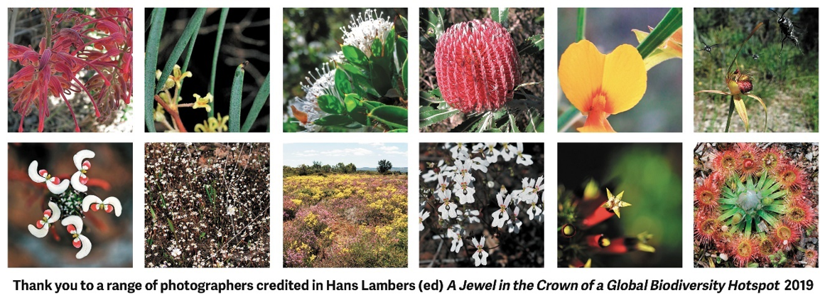

Implement evidence-based 100 metre buffer zone widths and locations that protect Yule Brook and GBSW and thus reconsider and reduce the development footprint as per The Beeliar Group (TBG) mapping. The Beeliar Group’s vision for a future Yule Brook Regional Park illustrates the importance of broad and connected buffers. Check out the full presentation on their website.
1
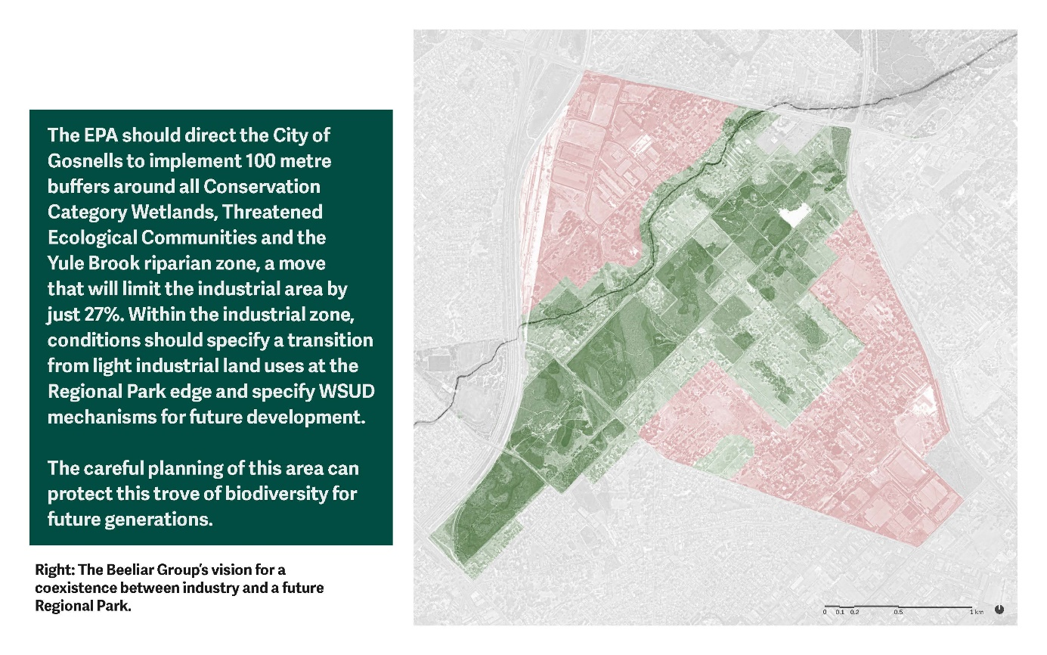
Functional buffers are required for good conservation management – without these, the significant natural wonders of the GBSW and proposed Yule Brook Regional Park will be eroded, degraded, and ultimately lost. These 100 metre buffers are required for:
- The Greater Brixton Street Wetlands (Bush Forever Site 387)
- All Conservation Category Wetlands
- Yule Brook riparian zone
- Crystal Brook riparian zone
- All Federal and State listed Threatened, Priority and other Flora of conservation significance and their habitat
- All vegetation of the Guildford and Forrestfield Vegetation Complexes
- All Federal and State listed Threatened, Priority and other Fauna of conservation significance (including invertebrates and Short Range Endemics) and their habitat (eg for Carnaby’s Black Cockatoos)
- All Federal and State Threatened Ecological Communities (TECs).
As per The Beeliar Group’s vision and the ecological requirement for 100 metre buffers, UBC urges the City of Gosnells (CoG) and the WA Planning Commission (WAPC) to NOT re-zone blocks within the 100 m buffer to ‘industrial’ or ‘composite zone’ (or ‘nominal drainage basin’ adjacent to Yule Brook). They contribute to the required critical buffer for keeping the hydrology intact and thus reducing detrimental impacts on vegetation, flora, and fauna. Bringing these blocks into public ownership to protect the environment will also mean that the current impact of roads dissecting the conservation area will be removed. The road network should be changed so that fully functional buffers can be implemented as the primary driver of infrastructure.
In addition, firebreaks must NOT be contained either within the boundary of the conservation areas nor the 100 metre buffer zones.
The Beeliar Group’s plan (supported by UBC) thus doubles the conservation/green area for a 27% reduction in the MKSEA industrial zoning (refer Figure 2). This would:
- improve connectivity of a future Yule Brook Regional Park
- reduce the boundary to area ratio of the conservation/green areas
- form a critical buffer to supporting and ameliorating the hydrological values and processes (thus reducing impacts on vegetation, Threatened and other flora and fauna) and
- reduce the impacts of industrial land use with inadequate buffers adjacent to GBSW.
2
Commission an independent, scientific, peer-reviewed and publicly transparent Water Management Strategy AUDIT and implement and monitor the resultant best practice Water Management Strategy. This would include review of the current Local Water management Strategies (LWMSs) and to design a new, best practice water management strategy and Structure Plan that will truly protect the GBSW and Yule Brook.
The current proposal will NOT provide adequate and appropriate ‘on-lot’ and ‘roadside’ water volume and quality structural controls to avoid and minimise the impacts of the planned MKSEA Precinct 2 and 3B water management on GBSW and Yule Brook. Moreover the ‘inherited’ cumulative impacts from other completed or planned projects will have very large and equally poorly mitigated/unmitigated impacts on the GBSW and Yule Brook (Figure 11 of the LWMS for MKSEA Precinct 2). These projects include the MKSEA Precincts 1 and 3A, the planned Tonkin Highway Grade Separated Interchanges (Hale Road and Welshpool Road) and other planned Kenwick/Wattle Grove and Forrestfield catchment industrialisation/urbanisation.
The LWMS for MKSEA Precinct 2 shows the inadequately-treated, polluted stormwater inflow from the large catchments of MKSEA Precinct 1, and the Wattle Grove and Tonkin Highway catchments is all planned for conveyance through the deep trapezoid open drain portion of Crystal Brook (in the iconic UWA Alison Baird Reserve in the GBSW) into Yule Brook.
Richards in his chapter ‘Impacts of urbanisation and conventional drainage infrastructure on the natural water cycle of Yule Brook, MKSEA’ (Lambers H ed (2019) p33-48) concludes “The conventional, conveyance stormwater management system proposed for MKSEA and the current CoG drainage development standards (which inform the MKSEA design) will adversely and irreversibly impact the Yule Brook and Kenwick Wetlands through significant augmentation to the existing (natural) water cycle and natural vegetated environment.
Vegetation within such diverse and rich environments are reliant on very specific surface water and groundwater sources. These various water sources contain as much diversity in constituents, volumes and depths. Augmentation to this diverse water system will adversely impact on the flora and fauna of the receiving environment.”
It is clear that at the time of publication of Lambers H ed (2019) the COG drainage practices were not delivering WSUD. The claims in the ERD therefore need to be carefully checked.
The LWMS must comply with latest version of WA Government ‘Decision Process for Stormwater Management in WA’, updated 2017 https://www.wa.gov.au/government/publications/decision-process-stormwater-management-western-australia. It is especially important for the GBSW that the State Government’s guidance for planning and designing stormwater management systems for urban developments be fully and carefully implemented. The first 15mm of any rainfall event needs to be managed on-lot, with estate wide management options also installed.
The challenge in ecologically sensitive urban environments consisting of hard, impervious surfaces is re-introducing the natural water cycle. One such approach is the application of Source Control Stormwater Management (SCSM) which replicates the natural water cycle within these impervious environments by avoiding the conveyance of stormwater as much as possible. The rationale behind SCSM is the management of stormwater as close to source as practically possible. The source management systems intercept stormwater surface runoff at the immediate location of runoff generation and can effectively manage all storm average recurrence intervals (ARIs) up to and including the 100 year storm event. The implementation of micro-catchments at source locations results in reduced surface runoff flow rates AND volumes that need to be considered for the drainage design and infrastructure.
They negate the requirement of surface detention systems similar to the Multiple Use Corridor (MUC) and the ‘nominal drainage basins’ being proposed. Such a revised design for LWMSs would also ensure improved environmental outcomes for the groundwater fed GBSW. By maximising triple-bottom-line benefits, SCSM counters the effects of traditional drainage systems that often result in harm to groundwater dependent ecosystems and critical habitat of Threatened wildlife.
In addition, the installation of detention basins by excavation, or other means, in the clay soils of the lowest lying parts of Precincts 2 and 3B is known to be risky with regard to the very serious impacts associated with acid sulphate soils and groundwater mounding in such settings.
3
Rigorously apply the Environmental Protection Authority’s (EPA’s) 2022 guidance provided in ‘Environmental Values and Pressures for the Greater Brixton Street Wetlands on the Swan Coastal Plain', in accordance with Section 16(j) of the Environmental Protection Act 1986’. Environmental Values and Pressures for the Greater Brixton Street Wetlands on the Swan Coastal Plain.pdf (PDF, 1.31 MB)
It specifically provides advice on expectations for proposals and planning schemes around:
- Traditional owner engagement
- Protection of ecological and hydrological values (note offsets statement)
- Hydrological and hydrogeological investigations
- Stormwater management and drainage
- Buffers
- Cumulative Impacts.
EPA Chair, Professor Tonts said the “EPA expected future activities and development to be compatible with the protection of the environmental values of the Greater Brixton Street Wetlands and would apply particular scrutiny to proposals and planning schemes that may be incompatible with the protection of these values.
“Protection of environmental values through science and coordinated management are critical if this unique area of biodiversity is to survive,” Professor Tonts said.
“This is a chance for us to be proactive and prevent further loss in what is one of the State’s most unique examples of biodiversity.”
The UBC strongly disagrees with the identical conclusions provided in ERD Table ES1: Assessment summary against the EPA’s Key Environmental Factors of ‘inland waters’, ‘terrestrial flora and vegetation’, ‘terrestrial fauna’ and ‘social surroundings’:
- Subject to the mitigation measures and planning mechanisms, the scheme amendments and associated development can be implemented in a manner which is likely to achieve the EPA objective.
The complexity of the hydroplain combined with the complexity of the ecological connectivity all builds towards a scenario that the GBSW will be irreversibly impacted.
In addition, ‘LIKELY to achieve’ is neither appropriate nor adequate. The proponent must demonstrate that they can achieve the objectives.
It is especially important to note that the Main Roads WA project “Tonkin Highway Grade Separated Interchanges (Hale Road and Welshpool Road)” will be a significant source of cumulative impacts on the GBSW.
4
Commission the first, ever, detailed fauna survey of the GBSW and MKSEA. The UBC highlights the oversight of this significant knowledge gap for this mega diverse habitat. Such research will clearly demonstrate the close relationships between the variety of plant community habitats and fauna, including with insects, Short Range Endemics and subterranean fauna.
This would ensure that analysis in the ERD is much better informed including the currently limited detail for Carnaby’s Cockatoos for which the IUCN Red List of Threatened Species (2022) highlights ‘As a result of extensive loss of feeding and breeding habitat, very rapid and continuing declines over the past three generations have been detected and further declines are almost certain. As a result, the species is classified as Endangered. ERD Appendix J (page 38) states “Carnaby’s black cockatoo also commonly occurs in the local area but as a regular (non breeding) seasonal migrant”.
Though many local Carnaby’s cockatoos move to the Darling Scarp for seasonal breeding, the juveniles and their minders remain on the SCP in a depleted foraging environment which has supports the main flocks from December to July. It is important to conserve and supplement this foraging resource as there is a very high attrition rate of the birds in their first year of life and their survival is critical for the long term species vigour. Foraging connectivity corridors are vital for these inexperienced birds who lack skills and stamina and are subject to increased attacks by territorial ravens and magpies.
Using contemporary science for Endangered Carnaby Cockatoos alone, recent flock movement studies by Prof. Kristen Warren and colleagues, at Murdoch University’s Harry Butler Institute and Keep Carnaby’s Flying, clearly demonstrate Carnaby’s rely on the patchwork of fragmented natural areas to move through the landscape. Whilst they may not roost or breed on each patch – being able to fly across, forage, bathe &/or rest are significant contributions of each neighbourhood patch, including the GBSW. https://www.murdoch.edu.au/research/hbi/case-studies/securing-the-future-of-black-cockatoos ).
A comprehensive fauna survey will also highlight the critical importance for faunal health and survival of being able to move through the landscape (via ecological linkages). Del Marco et al (2004); Molloy et al (2009) and Zelinova (2019), (2020) highlight the critical importance of ecological linkages and regional ecological linkages, not just between ‘patches of bush’, but ensuring there is also connectivity or ‘stepping stones’ between ‘like patches of bush’ eg wetland to wetland, banksia woodland to banksia woodland. For discussion on the importance of ‘ecological linkage/wildlife corridor’, the ERD refers to the 2000 Bush Forever documentation. Unfortunately, since its publication 23 years ago, many of the identified ecological linkages or greenways have been cleared and/or degraded. There is also need for active protection, regeneration and conservation management of these linkages.
As highlighted by Zelinova (2019) ‘the impacts of habitat fragmentation on biodiversity of a region are well documented.’ The proposed development on lands adjoining Yule Brook and the GBSW provides an opportunity to reduce the impacts of existing and future barriers to fauna movement between the wetlands and the nearby natural areas and establish a functioning ecological linkage between the Darling Scarp and the Canning River.

Ensure the Environmental Review Document (including Appendices) is predicated on contemporary knowledge . The Environmental Review Documents (ERD) prepared by Emerge Associates for the City of Gosnells, did not appear to make use of the most contemporary (and published) knowledge available from experts of the GBSW including:
5
- EPA (2015) Perth and Peel @ 3.5 million Environmental impacts, risks and remedies Interim strategic advice of the Environmental Protection Authority to the Minister for Environment under section 16(e) of the Environmental Protection Act 1986 https://www.epa.wa.gov.au/sites/default/files/Publications/Perth-Peel-s16e-interim-advice-2015-web.pdf
- EPA (2022) Environmental Values and Pressures for the Greater Brixton Street Wetlands on the Swan Coastal Plain', in accordance with Section 16(j) of the Environmental Protection Act 1986 Environmental Values and Pressures for the Greater Brixton Street Wetlands on the Swan Coastal Plain.pdf (PDF, 1.31 MB)
- Gao J, Wang F, Ranathunge K, Arruda AJ, Cawthray GR, Clode PL, He X, Leopold M, Roessner U, Rupasinghe T, Zhong H, Lambers H. 2020. Edaphic niche characterization of four Proteaceae reveals unique calcicole physiology linked to hyper-endemism of Grevillea thelemanniana. New Phytol 228: 869-883.
- Gao J, Wang F, Ranathunge K, Arruda AJ, Cawthray GR, Clode PL, He X, Leopold M, Roessner U, Rupasinghe T, Zhong H, Lambers H. 2020. Edaphic niche characterization of four Proteaceae reveals unique calcicole physiology linked to hyper-endemism of Grevillea thelemanniana. New Phytol 228: 869-883
- Lambers H ed (2019) A Jewel in the Crown of a Global Biodiversity Hotspot. Kwongan Foundation and the Western Australian Naturalists Club Inc, Perth.
With chapters from scientists, specialists and community including: Mike BAMFORD, Neale BOUGHER, Adam CROSS, Paddy CULLEN, Elaine DAVISON, Robert DAVIS, Tegan DOUGLAS, Katy EVANS, Sajni GUDKA, Bronwen KEIGHERY, Greg KEIGHERY, Karina KNIGHT, Megan JACEGLAV, Philip JENNINGS, Hans LAMBERS, Peter LANE, Owen RICHARDS, Cate TAUSS, Renata ZELINOVA.
- V & C Semeniuk Research Group (2001) Hydrological Study of the Greater Brixton Street Wetlands: Report prepared for the Friends of Brixton Street Inc.
The UBC believes the environmental impacts of the MKSEA proposal would have been more responsive and appropriate if more contemporary scientific knowledge was investigated and analysed.

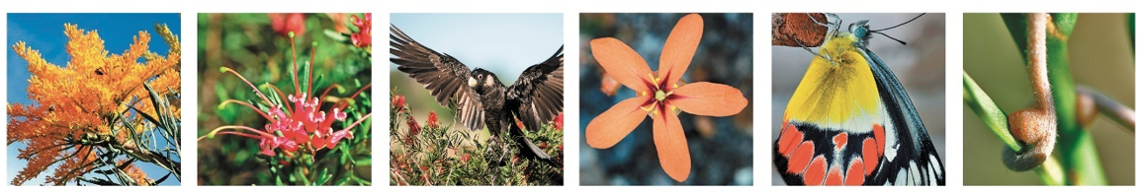
Intentionally plan and deliver the precautionary principle, intergenerational equity, conservation of biological integrity and waste minimisation as expected under the Environmental Protection Act 1986 (Section 4A)
6
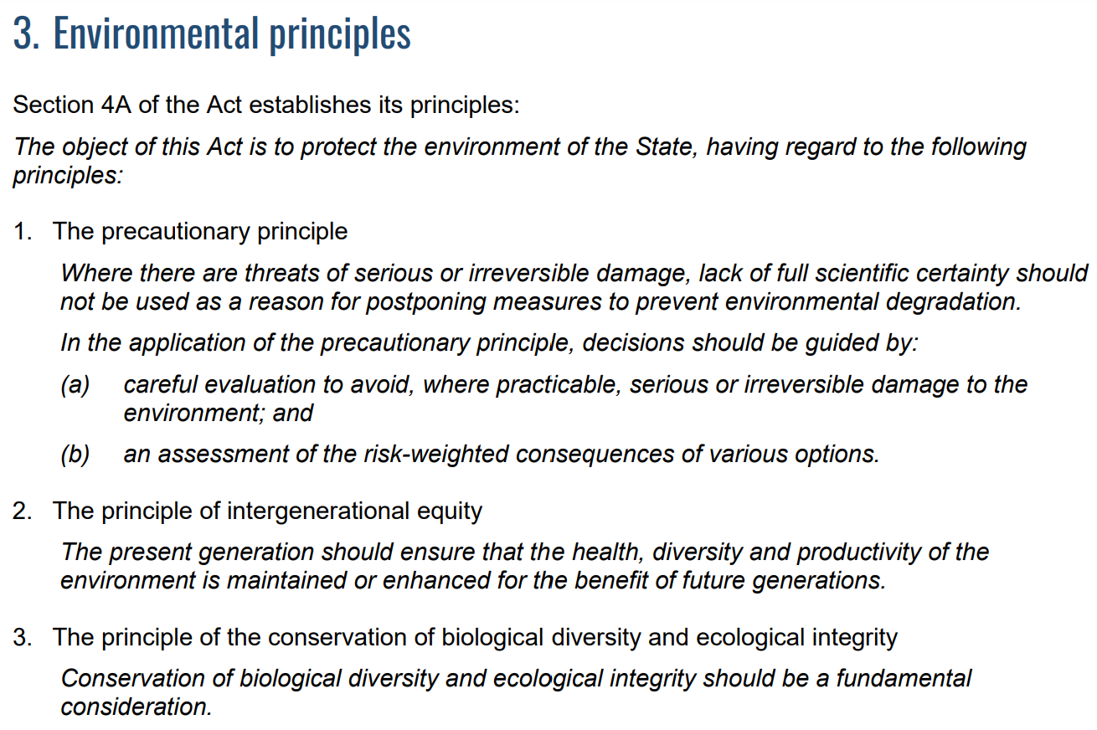
EXTRACT: Statement of environmental principles, factors, objectives and aims of EIA - 4 April 2023.pdf (PDF, 430.34 KB)
7
Intentionally plan and deliver against all relevant legislation, policies, commitments and standards of all three spheres of government to ensure hydrology, flora biodiversity, fauna biodiversity and ecological complexes are properly protected and managed including:
- Australian Government (2022) Nature Positive Plan
- Environment Protection and Biodiversity Conservation (EPBC) Act 1999 (eg Matters of National Environmental Significance (MNES) like Carnaby’s Black Cockatoos)
- Government of WA - Aboriginal Cultural Heritage Act 2021 – as per revision
- Government of WA - Biodiversity Conservation Act 2016
- Government of WA - Conservation and Land Management Act 2016
- Government of WA - Environmental Protection Act 1986 (amended 2021)
- Government of WA (2000) Bush Forever – Keeping the Bush in the City. Vol. 1-3
- Govt of WA (2022) Native vegetation policy for Western Australia (eg no net loss)
- Government of WA (1997) Wetlands Conservation Policy https://library.dbca.wa.gov.au/static/FullTextFiles/017818.pdf
- International Union for the Conservation of Nature IUCN (2022) COP 15 Global Biodiversity Framework
- The Beeliar Group (2018) A vision for conservation and public enjoyment of the Greater Brixton Street Wetlands and an eventual Yule Brook Regional Park. The Beeliar Group, Perth.
- Local Government Assn (2013) Policy-Advice-and-Advocacy/Environment/Local-Biodiversity-Program/Guidance-for-the-Integration-of-Biodiversity-into-LPSs.pdf.
8

Intentionally plan and deliver reconciliation with First Nations and implementation of all relevant legislation, policies, commitments and standards of all three spheres of government
Genuinely form a partnership with the Indigenous communities as knowledge holders and custodians of this Whadjuk Noongar boodja including delivering responsibilities under the Aboriginal Cultural Heritage Act 2021 or relevant changes as currently being developed and negotiated by the WA State Government.
Support and commendation of other community conservation group submissions
The UBC supports and strongly commends to you the considered and comprehensive submission made by other concerned community conservation groups including:
- The Beeliar Group
- Friends of Alison Baird Reserve
- Friends of Brixton Street Wetlands
- Nature Reserves Preservation Group
- Save the Great Brixton Wetlands Alliance
- The Wetlands Conservation Society
- Wildflower Society of WA and many other groups and individuals.

Conclusion
The Urban Bushland Council calls for much greater environmental protection of, and sustainable development around, our precious Greater Brixton Street Wetlands and Yule Brook corridor.
The impacts of these propose re-zonings to allow changed land uses to business development by industries (or to urban development) will have irreversible damaging impacts on the Greater Brixton Street Wetlands – a ‘Jewel in the Crown of a Global Biodiversity Hotspot’.
Hydrological changes outside of Bush Forever 387 (GBSW) and their impacts will especially affect the Guildford and Forrestfield Vegetation complexes and their flora and fauna on the Wetlands.
It is therefore strongly recommended that the City of Gosnells withdraws in full, these proposed Amendments 166 and 169, and that the precincts are not rezoned.
The UBC calls for the urgent creation of the Yule Brook Regional Park with adequate ongoing funding for conservation management and community awareness.
The UBC welcomes the opportunity to discuss its concerns with you.

Yours sincerely
___________________________________
Chairperson
Urban Bushland Council WA Inc
Urban Bushland Council WA Inc
City West Lotteries House
2 Delhi Street
West Perth WA 6005
ubc@bushlandperth.org.au
www.bushlandperth.org.au
CC  - Chair, WA Planning Commission  - Chair, Environmental Protection Authority  - Member for Thornlie  - Minister for Environment  - Secretary DCCEEW  - DCCEEW EPBCA Act section  - Town of Kalamunda (Mayor & CEO)  - City of Canning (Mayor & CEO)  - WA Local Government Association (CEO & CHAIR) | 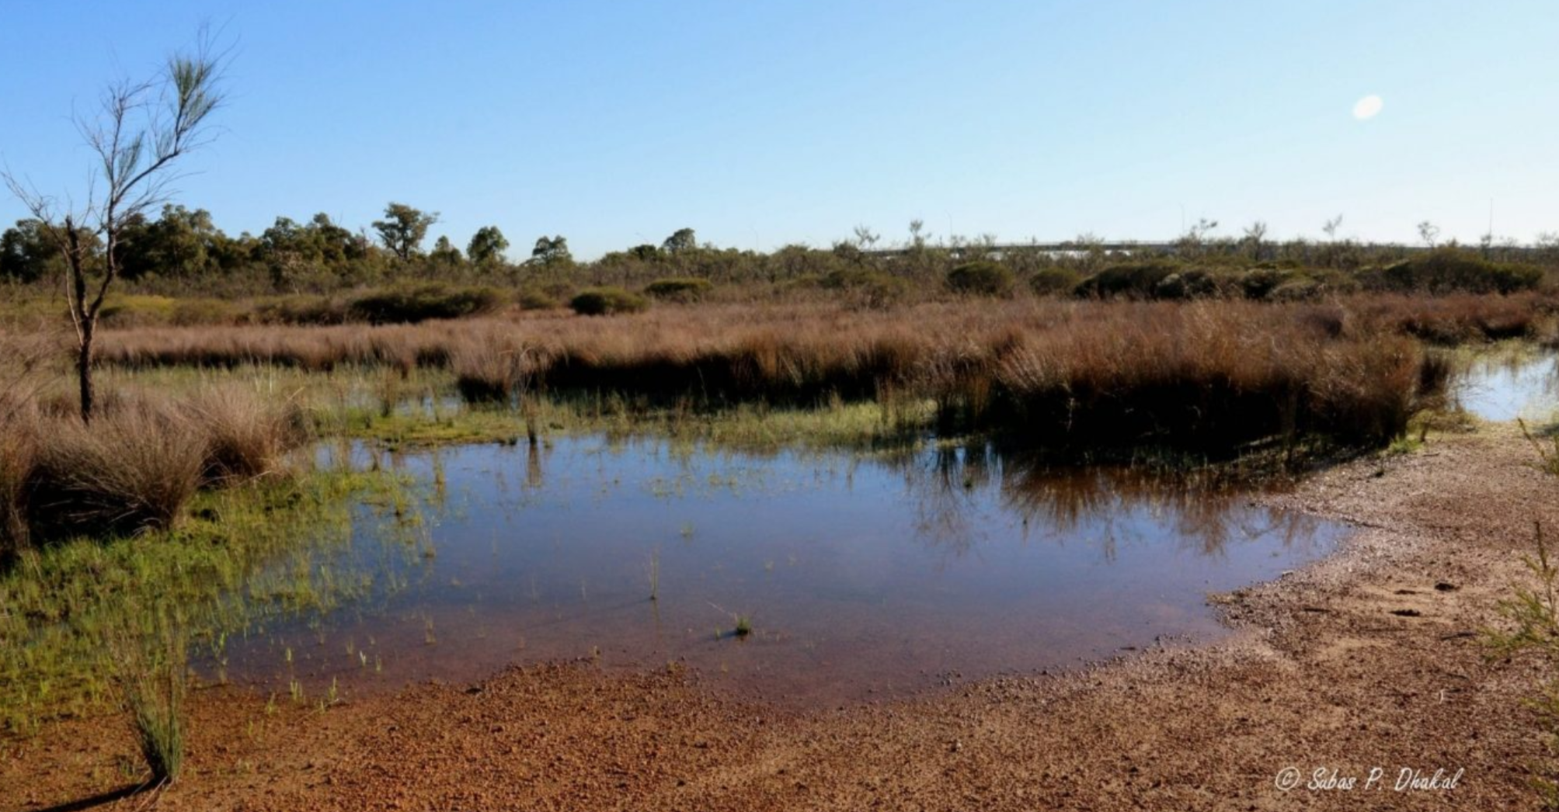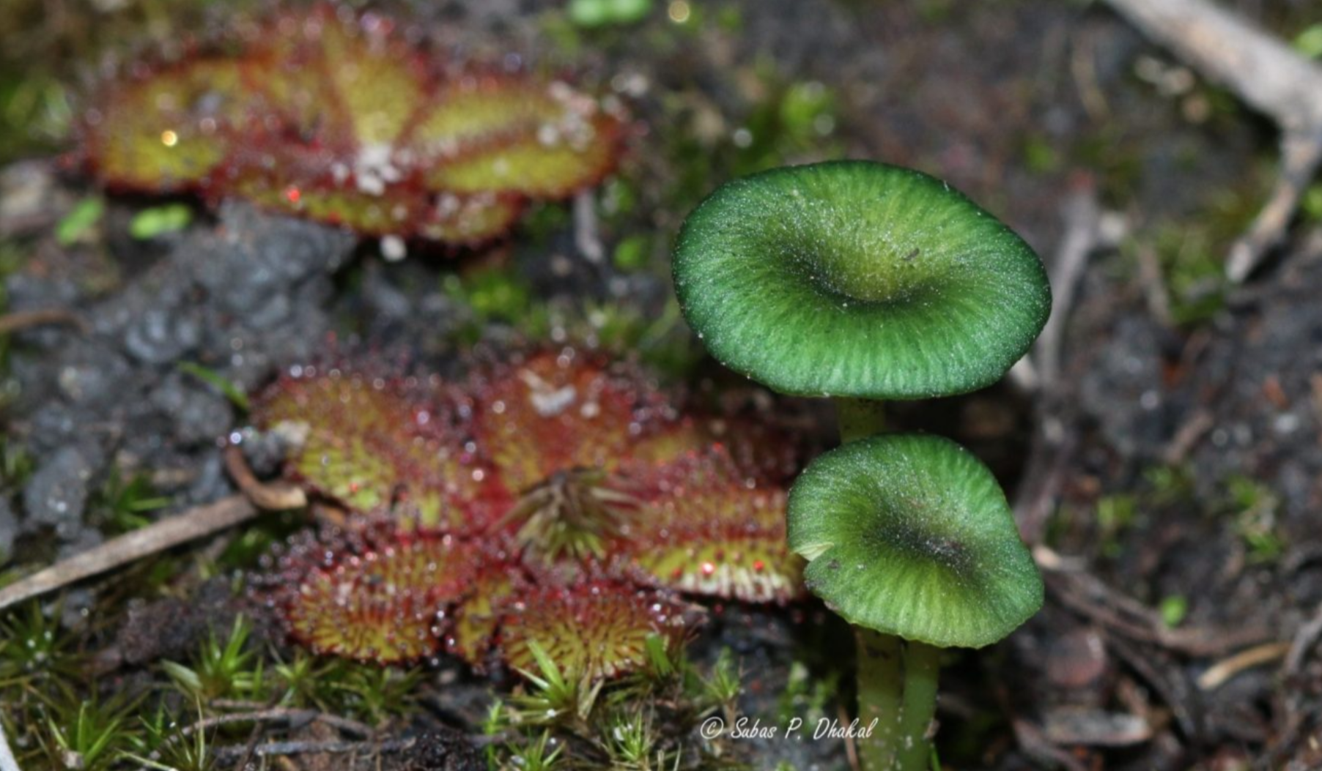  EXTRACT: UBC Urban Treasures Image credits: Sabas P Dhakal  https://www.bushlandperth.org.au/treasures/

