

Greater Perth holds the unenviable record for being the **worst city for tree canopy in Australia** – with only **16%** as determined in 2020 by the Department of Planning, Lands & Heritage (DPLH)

**UBC GUIDE to WA Government’s Urban Greening Public Survey**

Diminishing tree canopy, further clearing for housing developments, removal of mature trees on urban blocks, heat island effects, Polyphagus Shot Hole Borer (PSHB), a drying climate and a long hot summer that doesn’t want to end are all reasons why we should contribute to the development of the ‘Perth & Peel Urban Greening Strategy’.

The WA State government is committed to developing an urban greening strategy by the end of this year. They have a community survey out for comment, with a closing date of Friday 7th June.

<https://www.wa.gov.au/organisation/department-of-planning-lands-and-heritage/perth-and-peel-urban-greening-strategy>

Whilst the Urban Bushland Council (UBC) is pleased to see the WA Government focussing on ‘Urban Greening’ we are most concerned:

* The focus appears to be limited to ‘planted’ vegetation at the exclusion of natural areas
* Whilst the community is becoming better informed about the causes and impacts of ‘Urban Heat Island Effect’ and ‘Climate Change’ we still do not have an enforceable government and community target for ‘tree cover’ nor essential climate adaptation measures such as retaining vegetation (natural, private, public) to moderate the climate and provide habitat for wildlife
* Similarly, large trees and shrubs (that also provide temperature regulation, fauna habitat, aesthetics and carbon sequestration) are being cleared for residential, commercial, industrial and government developments – without consideration of their critical contribution to improving where we live &/or where of native plants and animals live
* Bushlands and wetlands are still being cleared
* Bush Forever Sites are still being cleared, disturbed &/or impacted (eg via impacts on hydrology, reduced buffers)
* Proposed Regional Parks (including Gnangara, Lower Serpentine, Swan & Helena Rivers, Peel and Yule Brook) are not being gazetted – whilst the quality of the vegetation communities is being affected by little or no active conservation management
* The allocated budget for good conservation management by the Department of Biodiversity, Conservation & Attractions (DBCA) continues to be totally inadequate
* Community groups are not listed as ‘stakeholders’ for Stage 2 of the consultation.

The ecological and wellbeing benefits of ‘tree canopy’ and ‘ecological linkages’ cannot be created in isolation of our natural areas. Natural areas make up a significant percent of the Perth and Peel canopy.   
As such, the Urban Bushland Council calls on the WA State Government to set and regulate a **30% Tree Canopy Target by 2040.**

**To meet such a target, native vegetation has a crucial role to play.** The following list identifies some of the ways we can protect our existing native vegetation canopy, thus mitigating the loss of canopy elsewhere from other human activities:

* increase the understanding in our governments and the community of the value and function of our natural areas and the important role they play in the urban canopy debate
* protect and manage those areas for conservation or we will lose canopy along with habitat
* redouble efforts to restore ecological communities within original ranges by active abatement of threats (eg illegal tracks, illegal rubbish dumping, weeds, fire, feral animals), revegetation, and other conservation initiatives
* **end clearing of the Swan Coastal Plain**

Between 2011 – 2020, canopy cover in Perth dropped 25%  
(WA Tree Canopy Advocates)

* acquire remaining sites and gazette all Bush Forever Sites for purpose of conservation, vesting in either Department of Biodiversity, Conservation & Attractions or Local Government Authorities
* assist community bushcare groups in their volunteer efforts to care for natural areas
* properly fund responsible agencies such as the Department of Biodiversity Conservation and Attractions (DBCA) for conservation management
* 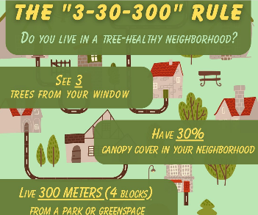include dedicated, informed community organisations in your extended community engagement including Urban Bushland Council (UBC), Birdlife WA (BWA), Ecovision, The Beeliar Group (TBG), WA Insect Study Society, WA Naturalists Club (WANats), WA Tree Canopy Advocates (WATCA), Wetlands Conservation Society (WCS), Wildflower Society of WA (WSWA) and.

*In your survey, don’t forget to ask for the* [***3:30:300*** *rule of thumb*](https://nbsi.eu/the-3-30-300-rule/) *– which provides clear criteria for the* ***minimum provision of urban trees & canopy in our urban communities****:*

* ***3 trees*** *seen from every home*
* ***30 % tree canopy cover*** *in every neighbourhood / suburb*
* ***300 metres*** *from the nearest public park or green space  
   – including natural bushland/wetland.*

*Does your neighbourhood / suburb meet this?*

GRAPHIC CREDIT: treeslouisville

**Other Guides for this ‘Urban Greening Strategy Survey’ we encourage you to dip into:**

|  |
| --- |
| **The Strategy: A Cloak of Sustainability**   * Lack of Legal Enforceability * An Inadequate Response to Ecological Crisis   **The Urgency of Legislative Reform**   * Preserving the rural zoned lands of Perth * Legislating Minimum Canopy Targets * Empowering Environmental Protections * Implement Stringent Penalties and Audits * Protect Ecologically Significant Sites * Enhancing the Support for Environmental Agencies   **Conclusion: Toward Substantive Environmental Reform**  [Find the report here.](https://www.bushlandperth.org.au/campaigns/your-voice-needed-now-on-key-issues/) |

[WATCA Guide](https://watca.org.au/pages/resources)

|  |
| --- |
| [A logo for a company  Description automatically generated](https://www.envirohouse.org.au/) [Enviro House](https://www.envirohouse.org.au/) |



|  |
| --- |
| **HOW TO USE OUR UBC GUIDE….**  UBC recommends adding…   1. Keep our UBC GUIDE open on your computer. 2. Open link to [WA Govt Urban Greening SURVEY](https://form.jotform.com/240349066160048) 3. Work thru your responses – whilst you refer back to our UBC GUIDE. 4. Sometimes we have recommended things to consider including in your responses. 5. Sometimes you might like to follow a link in our UBC GUIDE for more information. 6. SHARE this UBC GUIDE with EVERYONE – members of your group, family, neighbourhood, LGA, work, etc, etc. Encourage them to complete the survey too! 7. Contact UBC 9420 7207 or [ubc@bushlandperth.org.au](mailto:ubc@bushlandperth.org.au) if we can assist. 8. If you get a chance – give us some feedback! What worked well? & What could be improved? |

[WA Govt Urban Greening SURVEY](https://form.jotform.com/240349066160048)

UBC recommends adding…

NOTE: You can tick more than one.   
 Also take the opportunity to tell them about your volunteering efforts!

UBC recommends adding…

**WAPC & DPLH URBAN CANOPY DASHBOARD**

When you want to dig deeper and explore data for your suburb, LGA, local neighbourhood patch

<https://www.wa.gov.au/government/document-collections/better-urban-forest-planning-perth-and-peel#urban-tree-canopy-dashboard>

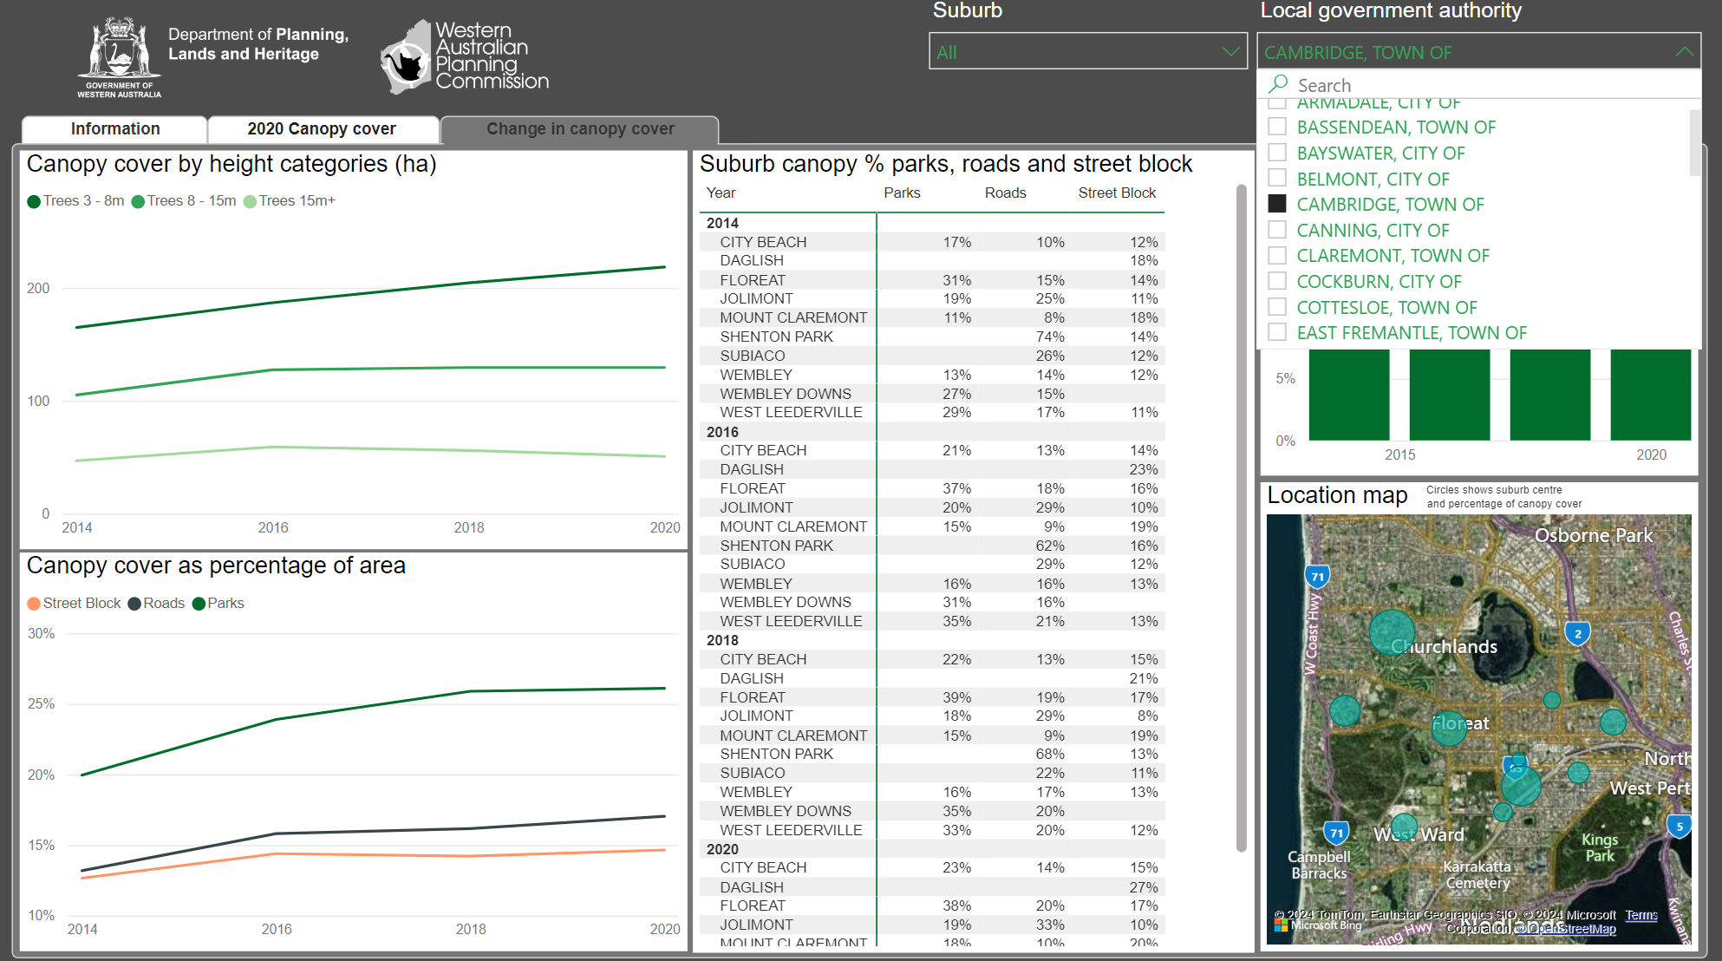

UBC recommends adding…

UBC recommends..

UBC recommends adding…

UBC recommends  
10 to 5 being …

NOTE: Personal response – Our Government needs to understand community levels of knowledge   
– so they can respond accordingly.

UBC recommends

UBC recommends

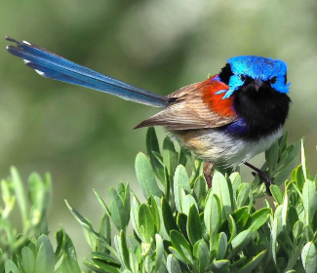**Urban Greening UNDERSTOREY for small animals**

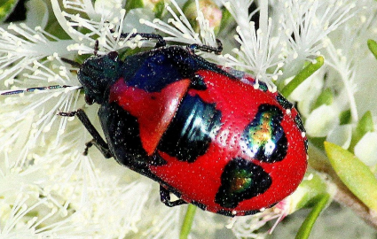Birds, insects, reptiles, frogs and other wildlife require shrubs, sedges, grasses, mosses, lichens, fungi – not just trees for connectivity in the urban landscape. Fragmentation caused by habitat removal severely impacts small resident native animals with small home ranges. Green understorey corridors have an important role to play in creating ecological links for these creatures and should be explicitly included in the urban greening strategy. These understory corridors should be of local native plant species to provide the most appropriate shelter and to avoid spreading invasive species. Characteristics of great understory corridors include plant diversity; use of local species; close planting to provide protection and contiguous plantings.

Purple-backed Fairy-Wren  
Mosman Park Bushlands [John Baas]

Jewel Beetle – Anstey-Keane Dampland [Bryony Fremlin, Friends of Forrestdale]

UBC recommends adding…

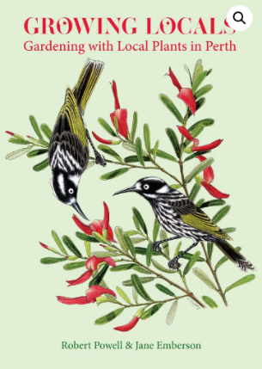

UBC recommends adding…

UBC recommends using **local native species** in plantings…

And buying & using this fabulous book that is specific for Perth!

Can be purchased from   
[WA Naturalists’ Club](https://www.wanaturalists.org.au/product/growing-locals-gardening-with-local-plants-in-perth/) and   
[Wildflower Society of WA](https://www.wildflowersocietywa.org.au/)

Revised EDITION 2024

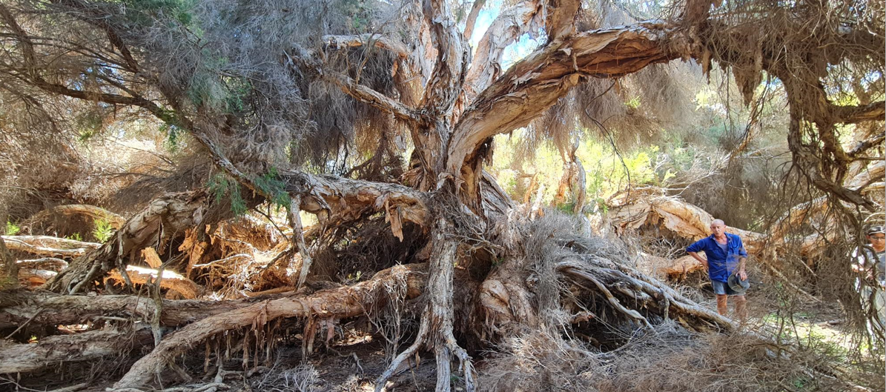**Polyphagus Shot Hole Borer (PSHB)** is a serious exotic pest that is killing WA trees and shrubs – both native and exotic. A major threat to our desire to increase urban canopy – and to our natural habitats.

**300 year old Swamp Paperbark *(Melaleuca rhaphiopylla)* at Lake Claremont** – that is to be removed as has been infected with PSHB. An amazing giant, felled by a tiny beetle and its fungus. Its scale is demonstrated by Nick Cook (WA Tree Canopy Advocates & Frields of Lake Claremont) and Jasmin Nivethitha (UBC Intern). Imagine all the insects, reptiles, birds that are going to lose their habitat. And the cultural history that it has witnessed. **We are losing trees, canopy, habitat and Perth’s SENSE OF PLACE** [Colma Keating 12/3/2024]

You may be aware of the devastation it is causing in Lake Claremont, Kings Park and Hyde Park.

The beetle carries a fungus in its mouth – this infects the tree as the beetle bores in and destroys the plant’s living cells and kills the host tree. There is no cure. The is no chemical or biological control. The only treatment is tree pruning or removal and then chipping. In just over 3 years, it has spread to 80% of the Perth Metropolitan Area (now in quarantine) and is already having an impact on our urban greening. Further control methods are required.  
The Department of Primary Industries and Regional Development (DPIRD) is the lead agency (<https://www.agric.wa.gov.au/borer>). This link gives you quarantine area and rules to help limit pest, ID tips & tools and a list of HOST PLANTS including WA natives.

UBC recommends adding…

**NatureLink Perth** provides a hub for people and organisations to work together to conserve our biodiversity or integrate nature into our city. We must embrace nature in the city if we are to sustain our unique plants and animals into the future.   
NatureLink Perth WA actively works with ‘friends of groups’ to identify, design and partner in ecological linkages connecting natural areas across our suburbs. Their resources are innovative and practical <https://www.naturelinkperth.org/resources/>

Make sure you subscribe to their informative & stimulating NEWSLETTER.

**______________________________________________________________**

**Urban Bushland Council also encourages you to check out these other organisations that have very useful information and links**

[WA Tree Canopy Advocates](https://watca.org.au/) [Wetlands Conservation Society](https://wetlandswa.org.au/) [Wildflower Society of WA](https://www.wildflowersocietywa.org.au/)

](https://www.envirohouse.org.au/)

[Peel Harvey Catchment Council](https://peel-harvey.org.au/) [Birdlife WA](https://birdlife.org.au/groups/birdlife-wa/) [Enviro House](https://www.envirohouse.org.au/) [ReWild Perth](https://rewildperth.com.au/)  
 Perth NRM

NatureLink Perth

**______________________________________________________________**